Dissertation dev log
Week 22:
Current Goals for Full Dissertation session:
- Specification for computing artefact that integrates societal, user, and business needs, demonstrating impact, usability and values to stakeholders
- Design rational, usage guidance, maintainability and architecture overview are provided
- Statistics addendum
- Artefact testing
Completed:
- Abstract
- Workplan make clearer
- Research question made more precise and naturalistic
- Critical addendum
- Results and analysis section
- Discussions and conclusion
- Analyse data
- Gather data
- A way to interact with the fragmented mesh
- A working Voronoi fracture in 2D for demonstration
- Working Voronoi fracture in 3D
- Comprehensive background done, covering triangulation, fracturing methods used in games, Graphics API’s, Performance of Graphics API’s, Point sampling, and Voronoi Clipping.
- Clearly stated research question
- Clear, feasible hypothesis, that is well scoped.
- An introduction that provides clear context for the project, and explains the need for the research, including positive impacts and who benefits. It should also highlight the motivation for the project.
- Professional, ethical, sustainable, legal, and social review carried out.
- A plan for security and privacy concerns has been written, and data is well managed.
- A methodology for how the project is going to be researched, and how its going to be evaluated
- A working way of profiling the results of the prototype
- Voronoi clipping implemented

- A Critical Review of current technology is completed, that highlights where the gap in research is, and the how this project fills it.
- Project is ethically robust
- Project plan with gantt chard
- Profiling results that are easily replicated and are well documented.
- Fracture implemented in both OpenGL and Vulkan
- Readme that highlights development roadmap
- OpenGL integrated into bridge system
- An implementation in GLSL, for performance comparison

Bugs
- OpenGL buffering of data has to be done In a specific order, i.e., declare positions, then buffer it, then declare textures, and then buffe them
- Mesh needs tetrahedralization, which means constrained Delaunay triangulation

Development notes:
This week I received feedback from professors that I could be using a different graph and statistical test to better analyse my data, and produce results in a broader area. This was to use a lineplot instead of a boxplot, and to analyse my data on many point set sizes, i.e. 2-100, instead of just 10 and 100. This would allow me to identify the general performance trend of both OpenGL and Vulkan, instead of on a very specific point set, and allow my results to be broader despite my hardware limitations. The statistical test change from man-whitney to a multiple linear regression test was suggested as this would better allow me to identify statistical significance, and identify coefficients between variables, to analyse how the interact with each other. This week was spent rewriting my artefact to re-collect the data required to perform this, recollecting this data, and re-writing the python code to re-analyse the data. I have switched from using pandas to using seaborn for my lineplot, as it was recommended by the professor.
Images:
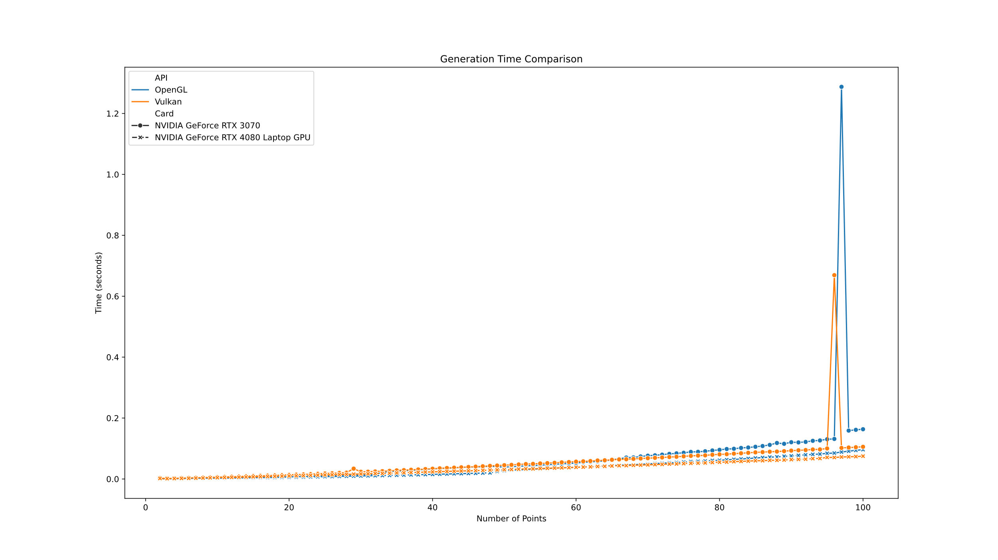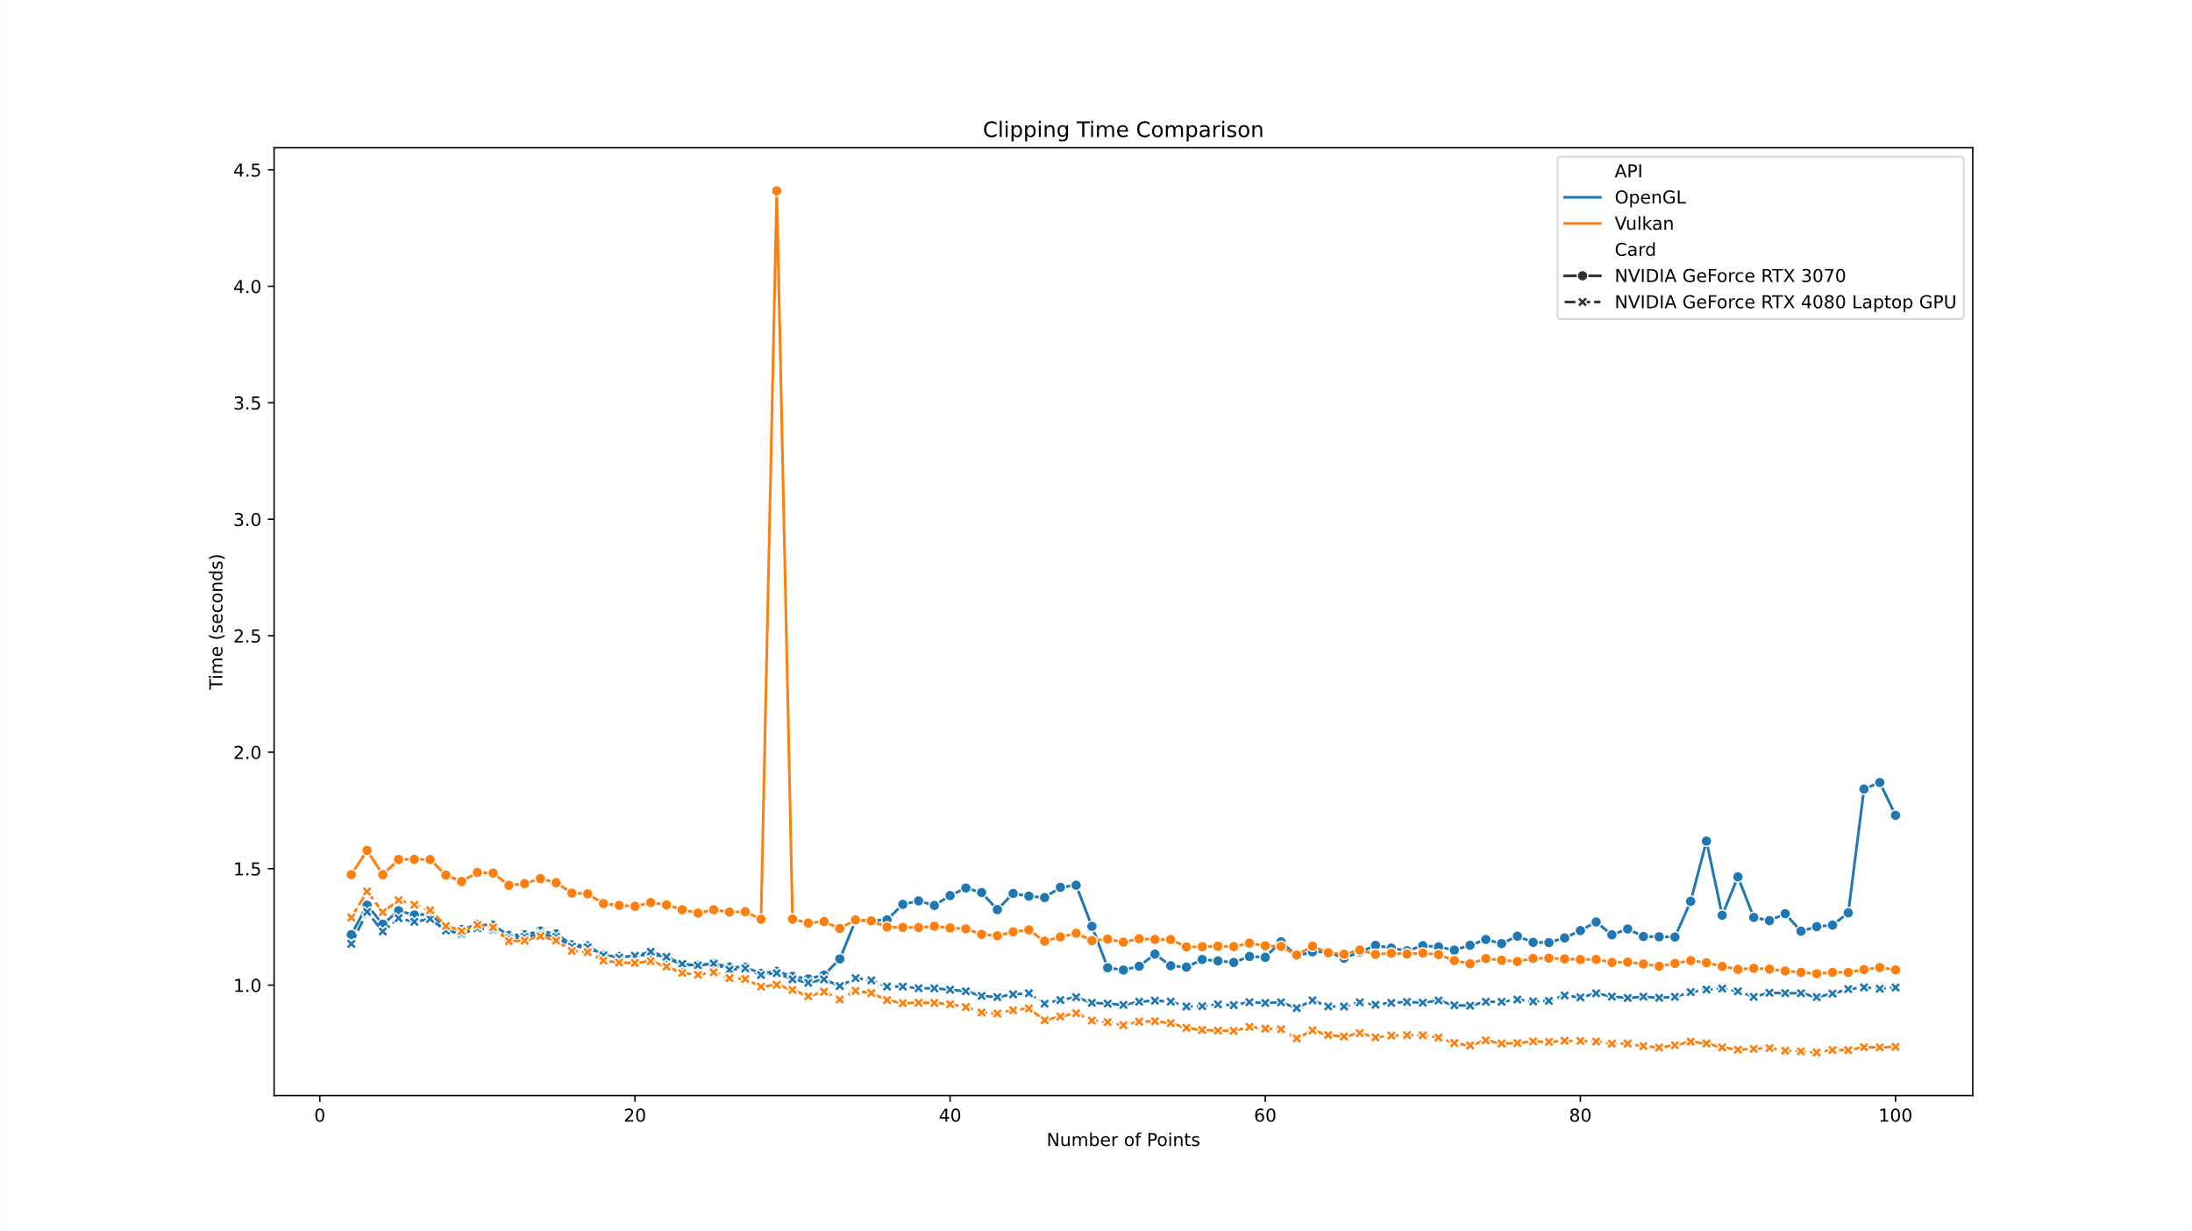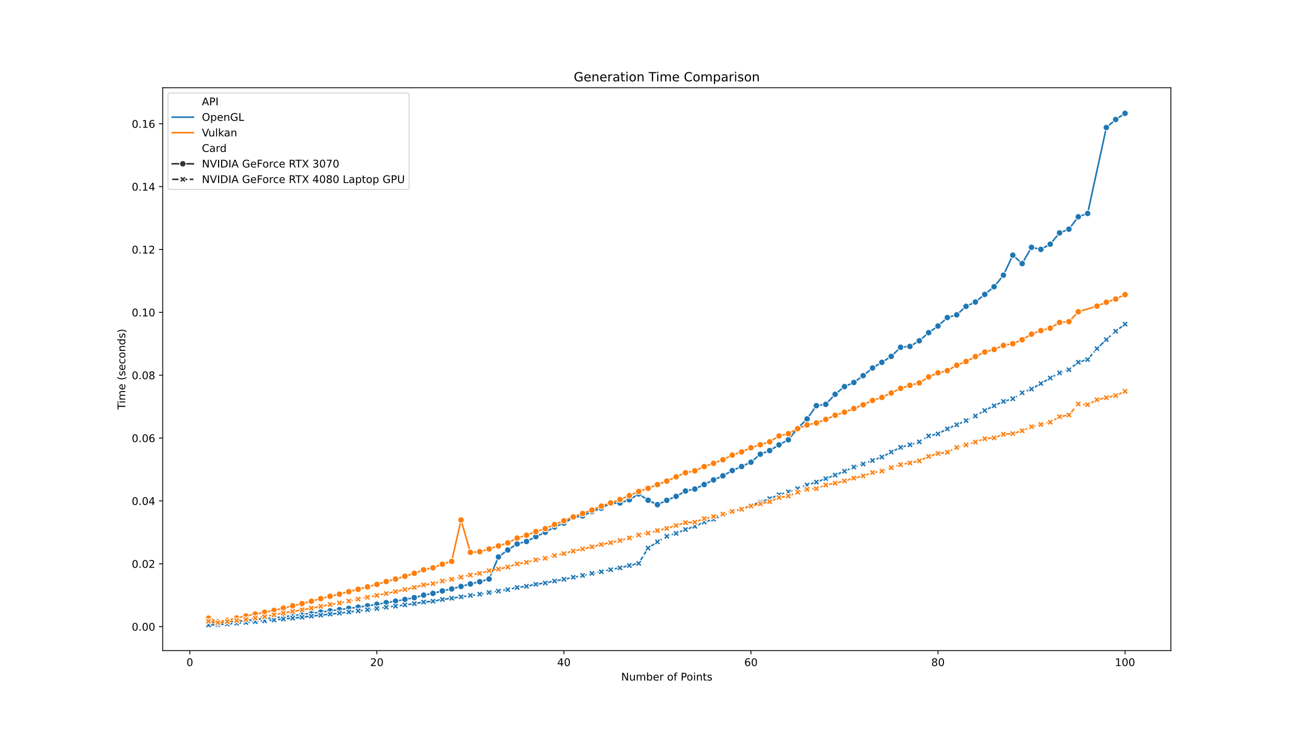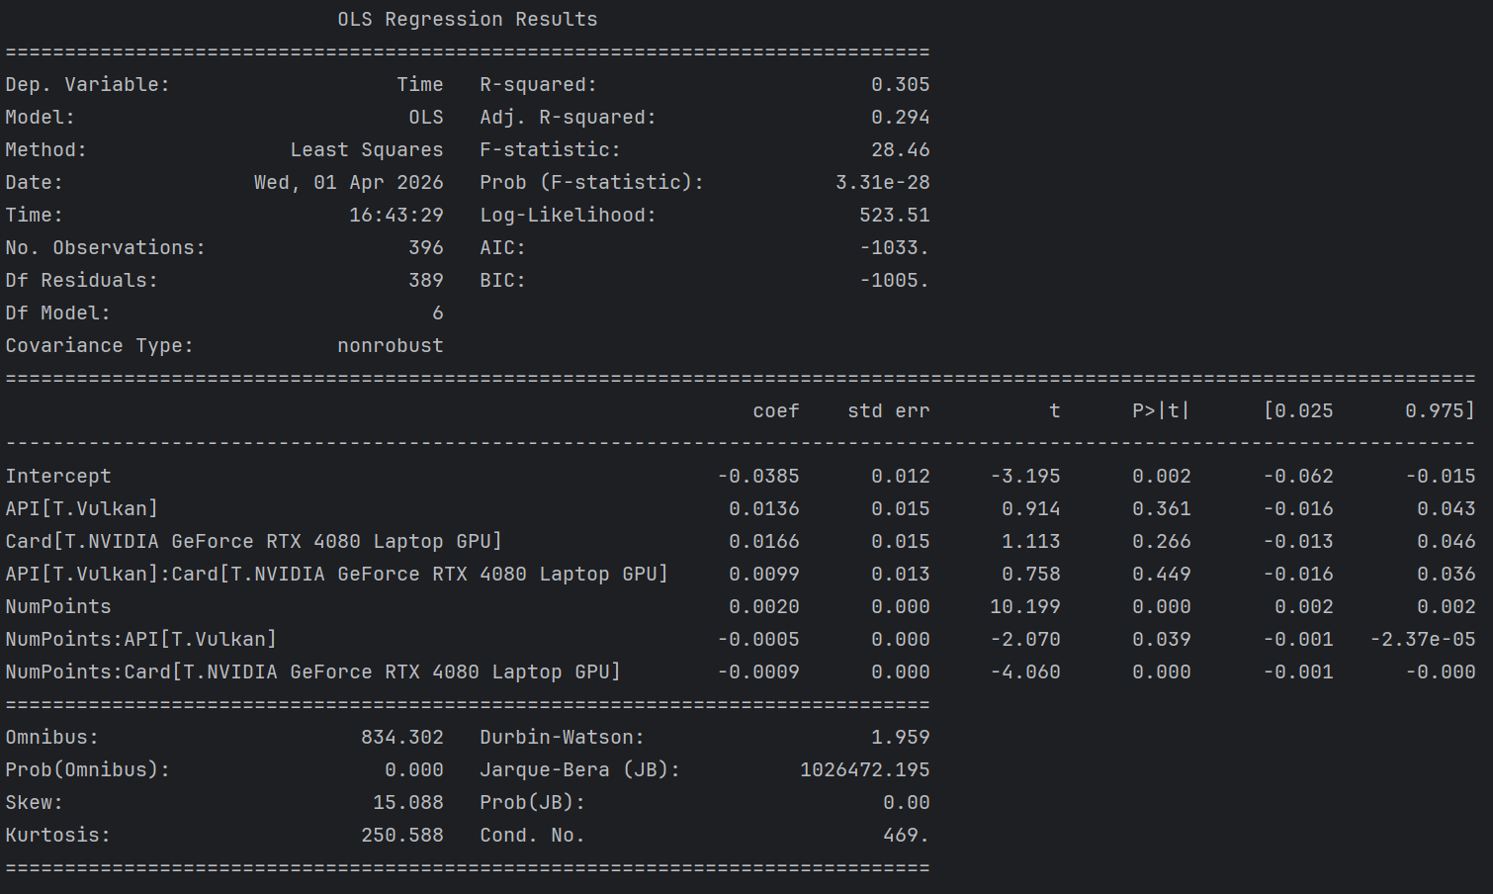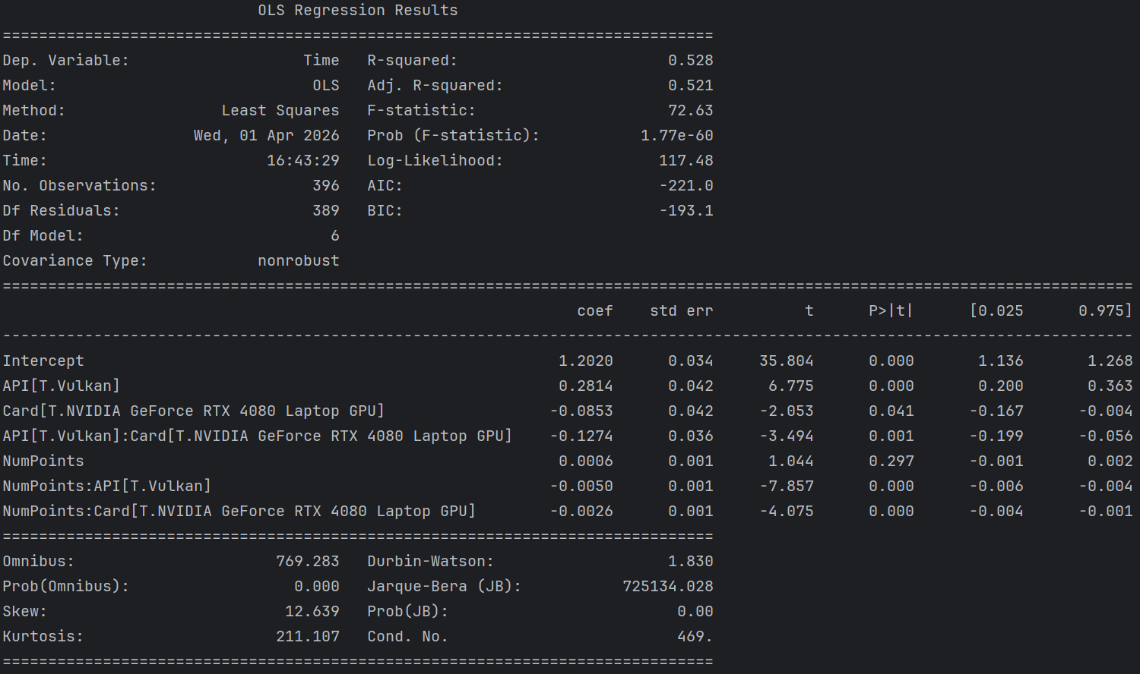

References:

